**PNEUMONIA DETECTION**

**MINOR PROJECT REPORT SUBMITTED IN THE PARTIAL FULFILLMENT OF THE REQUIREMENT FOR THE AWARD OF THE DEGREE**

**OF BACHELOR IN TECHNOLOGY**

**IN**

**COMPUTER SCIENCE AND ENGINEERING**

**DATA ANALYTICS**

**BY**

NAME OF THE STUDENT:

*Subhadip Samanta*

*Wrishav Sett*

*Sudipta Saha*

ROLL NO.:

*TNU2020021100001*

*TNU2020021100004*

*TNU2020021100005*

UNDER THE SUPERVISION OF

Dr. Usha Rani Gogoi

ASSISTANT PROFESSOR, Dept. of Computer Science and Engineering, TNU

**Dept. of Computer Science of Engineering**

**THE NEOTIA UNIVERSITY, WEST BENGAL, INDIA**

**November, 2023**

**Acknowledgement**

I would like to express my profound gratitude to ________________, of Computer Science Engineering Department of The Neotia University for their contributions to the completion of my project titled Object Detection.

I would like to express my special thanks to our mentor Mr./Mrs. ________________ for his/her time and efforts he/she provided throughout the year by supporting us and pointing us in the right direction. Your useful advice and suggestions were really helpful to me during the project’s completion. In this aspect, I am eternally grateful to you.

I would like to acknowledge that this project was completed entirely by me and not by someone else.

Signature

Your name

**Certificate**

We hereby recommend that the Project entitled “**Pneumonia Detection**” worked under our guidance may please be accepted in the partial fulfillment of the requirement for the degree of “Bachelor in Technology” in the Computer Science and Engineering with specialization in Data Analytics of ‘The Neotia University’. The project report in our opinion is worthy for its acceptance. During the work students – ‘**Subhadip Samanta**’ was found to be sincere, regular and hardworking and have successfully completed the thesis work assigned to him.

________________ ________________

(HOD/TIC, CSE) Dr. Usha Rani Gogoi

The Neotia University The Neotia University

**Certificate**

We hereby recommend that the Project entitled “**Pneumonia Detection**” worked under our guidance may please be accepted in the partial fulfillment of the requirement for the degree of “Bachelor in Technology” in the Computer Science and Engineering with specialization in Data Analytics of ‘The Neotia University’. The project report in our opinion is worthy for its acceptance. During the work students – ‘**Wrishav Sett**’ was found to be sincere, regular and hardworking and have successfully completed the thesis work assigned to him.

________________ ________________

(HOD/TIC, CSE) Dr. Usha Rani Gogoi

The Neotia University The Neotia University

**Certificate**

We hereby recommend that the Project entitled “**Pneumonia Detection**” worked under our guidance may please be accepted in the partial fulfillment of the requirement for the degree of “Bachelor in Technology” in the Computer Science and Engineering with specialization in Data Analytics of ‘The Neotia University’. The project report in our opinion is worthy for its acceptance. During the work students – ‘**Sudipta Saha**’ was found to be sincere, regular and hardworking and have successfully completed the thesis work assigned to him.

________________ ________________

(HOD/TIC, CSE) Dr. Usha Rani Gogoi

The Neotia University The Neotia University

**Declaration of Originality and Compliance of Academic Efforts**

I hereby declare that this report contains literature survey and original research work done by the under signed candidates, as part of our “**Bachelor in Technology Studies**”.

All information in this document have been obtained and presented in accordance with academic rules and ethical conduct.

I also declare that, as required by these rules and conduct, I have cited and referenced all materials that are not original to this work.

Name: Subhadip Samanta

Roll No.: TNU20220021100001

Project Title: **Pneumonia Detection**

Signature with Date:

**Declaration of Originality and Compliance of Academic Efforts**

I hereby declare that this report contains literature survey and original research work done by the under signed candidates, as part of our “**Bachelor in Technology Studies**”.

All information in this document have been obtained and presented in accordance with academic rules and ethical conduct.

I also declare that, as required by these rules and conduct, I have cited and referenced all materials that are not original to this work.

Name: Wrishav Sett

Roll No.: TNU20220021100004

Project Title: **Pneumonia Detection**

Signature with Date:

**Declaration of Originality and Compliance of Academic Efforts**

I hereby declare that this report contains literature survey and original research work done by the under signed candidates, as part of our “**Bachelor in Technology Studies**”.

All information in this document have been obtained and presented in accordance with academic rules and ethical conduct.

I also declare that, as required by these rules and conduct, I have cited and referenced all materials that are not original to this work.

Name: Sudipta Saha

Roll No.: TNU20220021100005

Project Title: **Pneumonia Detection**

Signature with Date:

**Abstract**

Pneumonia, an interstitial lung disease, is the leading cause of death in children under the age of ﬁve. It accounted for approximately 16% of the deaths of children under the age of ﬁve, killing around 880,000 children in 2016 according toa study conducted by UNICEF. Affected children were mostly less than two years old. Timely detection of pneumonia in children can help to fast-track the process of recovery. This paper presents convolutional neural network models to accurately detect pneumonic lungs from chest X-rays, which can be utilized in the real world by medical practitioners to detect pneumonia. Experimentation was conducted on Chest X-Ray Images (Pneumonia) dataset available on Kaggle with multiple pretrained and custom CNN models.

**Introduction**

**1.1 What is Pneumonia? Symptoms, Cause and Diagnosis**

**1.1.1** Pneumonia is a respiratory infection that inflames the air sacs in one or both lungs. The air sacs may fill with fluid or pus, causing symptoms such as cough with phlegm or pus, fever, chills, and difficulty breathing. Pneumonia can be caused by various microorganisms, including bacteria, viruses, and fungi.

Pneumonia can affect anyone, but certain groups, such as infants, the elderly, and individuals with weakened immune systems, are more susceptible to severe complications. Prompt diagnosis and appropriate treatment, often including antibiotics for bacterial pneumonia or antiviral medications for viral pneumonia, are essential for a successful recovery.

Preventive measures include vaccinations against common pathogens, good hygiene practices, and maintaining a healthy lifestyle. The most common vaccines for preventing pneumonia include the pneumococcal vaccine and the influenza vaccine.

**1.1.2** Common symptoms of pneumonia include:

* Cough
* Fever
* Shortness of Breath
* Chest Pain
* Fatigue
* Rapid Heart Rate
* Bluish Discoloration
* Confusion (especially in older adults)

It's important to note that symptoms can vary, and some people, especially those with weakened immune systems, may experience atypical symptoms. In children, symptoms may include fast breathing, wheezing, and retractions (when the skin between the ribs pulls in during breathing).

**1.1.3** Common causes of pneumonia include:

* Bacterial Infections
* Viral Infections
* Fungal Infections
* Aspiration:
* Chemical Irritants:
* Hospital-Acquired Pneumonia (HAP)
* Community-Acquired Pneumonia (CAP)

**1.1.4** Diagnosis for pneumonia:

* Clinical Evaluation:
  + Medical history and physical examination.
  + Chest X-ray: To visualize the extent and location of inflammation.
  + Blood tests: To identify the causative agent.
* Microbiological Tests:
  + Sputum culture: Identifies bacteria causing the infection.
  + Blood cultures: Detects bacteria in the bloodstream.
* PCR tests: Identifies viral or fungal DNA.
* Imaging Studies:
  + CT scans: Provides detailed images of the lungs.

**1.1.5** Treatment:

* Antibiotics:
  + Bacterial pneumonia: Treated with antibiotics such as amoxicillin, azithromycin, or levofloxacin.
* Antiviral and Antifungal Medications:
  + Viral pneumonia: Antiviral drugs may be prescribed (e.g., oseltamivir for influenza).
  + Fungal pneumonia: Antifungal medications like fluconazole or voriconazole.
* Supportive Care:
  + Oxygen therapy: Administered in severe cases to maintain oxygen levels.
  + Fluids and rest: Important for recovery.

**1.1.6** Prevention:

* Vaccination:
  + Pneumococcal vaccine: Protects against the most common cause of bacterial pneumonia.
  + Influenza vaccine: Reduces the risk of viral pneumonia.
* Good Hygiene Practices:
  + Frequent handwashing.
  + Avoiding close contact with sick individuals.
* Healthy Lifestyle:
  + Adequate nutrition and exercise.
  + Avoiding smoking and excessive alcohol consumption.

**1.2 What is Machine Learning?**

Machine Learning (ML) is a subset of artificial intelligence (AI) that focuses on the development of algorithms enabling computers to learn and make predictions or decisions without being explicitly programmed.

Types of Machine Learning:

* Supervised Learning
* Unsupervised Learning
* Semi-supervised Learning
* Reinforcement Learning

**1.3 What is Deep Learning?**

Deep Learning is a subset of machine learning that involves neural networks with multiple layers (deep neural networks). It is based on the structure of a neuron from a human brain.

Applications of Deep Learning:

* Computer Vision tasks: Image Classification, Object Detection and Image Generation.
* Natural Language Processing
* Speech Recognition
* Healthcare: Medical Image Analysis and Disease Prediction.

**1.4 What are CNN’s?**

Convolutional Neural Networks (CNNs) are a class of deep neural networks primarily designed for processing and analyzing visual data, such as images and videos. CNNs have been widely successful in various computer vision tasks and are characterized by their ability to automatically and adaptively learn spatial hierarchies of features from input data.

Key components of a CNN include:

**1.4.1 Convolutional Layers:** These layers use convolutional operations to scan the input data with a set of filters or kernels, extracting features like edges, textures, or patterns. These filters are small, learnable matrices that slide over the input data.

**1.4.2 Activation Function:** After convolutional operations, an activation function (commonly ReLU - Rectified Linear Unit) is applied to introduce non-linearity, allowing the network to learn more complex relationships in the data.

**1.4.3 Pooling (Subsampling or Down-sampling) Layers:** Pooling layers reduce the spatial dimensions of the input data by down sampling. This helps in decreasing the computational complexity and the number of parameters in the network.

**1.4.5 Fully Connected Layers:** After several convolutional and pooling layers, the high-level reasoning in the neural network is done through fully connected layers. These layers connect every neuron in one layer to every neuron in the next layer, forming the final output.

**1.4.6 Flattening:** Before feeding the output from the convolutional/pooling layers to the fully connected layers, the data is typically flattened into a one-dimensional array.

**Objective and Scope**

**2.1** The health organization has suffered from the lack of diagnosis support systems and physicians. Furthermore, the physicians are struggling to treat the overwhelming number of patients, and the hospitals also have the lack of a radiologist especially in rural areas. Hence, almost all cases are handled by a single physician, leading to many misdiagnoses. Computer aided diagnostic systems are being developed to address this problem. The current study is aimed to review the different methods to detect pneumonia using neural networks and compare their approach and results.

According to the World Health Organization (WHO), the best way to detect pneumonia is currently through computed tomography (CT) scans. Further, imaging has a vital role in detection and management of pneumonia as T. Franquet, proposed that imaging examination should always begin with a conventional radiography, and CT is only required when the radiography results are inconclusive. A chest X-ray is most commonly recommended to patients with uncertain causes of pneumonia.

From the chest X-ray the pneumonia can be classified into 4 categories, including lobar pneumonia, bronchopneumonia, lobular pneumonia, and interstitial pneumonia. These 4 different classifications may have quite a lot of variations from between patients, changing with different types of pneumonia. Therefore, the classification of pneumonia is considered a difficult task. As such for our use case we have adhered to only checking for the presence of pneumonia in the X-ray of an individual’s chest making our project a binary classification project.

In this project, our objective is to implement different variants of pre-trained CNN models as well as custom CNN models and evaluated their performance.

Once a respectable model is trained with a performance score that is approved by medical standards which properly identifies the presence of pneumonia, the project can be utilized in the medical field for detection of pneumonia. It is our intention to make it into a widely available project so that even the less privileged can have the opportunity to check their medical condition without incurring any significant costs in the early stages.

Since this is a classification project the same models and approach used can also be used for similar diseases to check for the presence of the disease through the proper data the models would be trained on.

**Problem Statement**

**3.1** Our goal for this project was to use multiple pretrained models and also create custom CNN models to detect the presence of pneumonia in a person’s chest X-ray.

We would then compare the performance of the various models implemented and select the best out of them all and use said model to write a code to detect the presence of pneumonia.

Once done we would then move on to create a user-friendly frontend to deploy our project so that it is accessible to all. Before that we would need to get the performance model and the feasibility of the model checked and approved according to the proper medical standards.

**Literature Review**

**4.1** Pneumonia detection using chest X-rays has been an open problem for many years, the main limitation being the scarcity of publicly available data. Traditional machine learning methods have been explored extensively. Chandra et al. [11] segmented the lung regions from chest X-ray images and extracted eight statistical characteristics from these regions, which they used to classify them. They implemented five traditional classifiers: multi-layer perceptron (MLP), random forest, sequential minimal optimization (SMO), classification via regression, and logistic regression. They evaluated their method on 412 images and achieved a 95.39% accuracy rate using the MLP classifier. Kuo et al. [12] used 11 features to detect pneumonia in 185 schizophrenia patients. They applied these features in a large number of regression and classification models, such as decision trees, support vector machines, and logistic regression, and compared the results of the models. They achieved the highest accuracy rate, 94.5%, using a decision tree classifier; the other models fell short by large margins. Similarly, Yue et al. [13] used 6 features to detect pneumonia in chest CT scan images of 52 patients; the best AUC value they achieved was 97%. However, these methods cannot be generalized and were evaluated on small datasets.

In contrast to machine learning algorithms, for which handcrafted features need to be extracted and selected for classification or segmentation, deep learning-based methods perform end-to-end classification, where the relevant and informative features are automatically extracted from the input data and classified. CNNs are preferred for image data classification because they automatically extract translationally invariant features through the convolution of the input image and filters. CNNs are translationally invariant and perform better than machine learning or traditional image processing methods in image classification tasks and thus are widely used by researchers.

Sharma et al. [14] and Stephen et al. [15] devised simple CNN architectures for the classification of pneumonic chest X-ray images. They used data augmentation to compensate for the scarcity of data. Sharma et al. obtained a 90.68% and Stephen et al. a 93.73% accuracy rate on the dataset provided by Kermany et al. [16], hereafter called the Kermany dataset. Data augmentation, however, provides only a limited amount of new information from which the CNNs can learn and thus may not significantly boost their performance. Rajpukar et al. [17] used the DenseNet-121 CNN model for pneumonia classification but achieved only a 76.8% f1-score for classification. They suspected that the unavailability of patient history was a major cause for the inferior performance of both their deep learning model and the radiologists with which they compared the performance of their method.

To solve the data scarcity problem in biomedical image classification tasks, transfer learning, wherein knowledge gained from a large dataset is used to fine-tune the model on a current small dataset, is currently a frequently used approach. Recently, Rahman et al. [6], Liang et al. [7], Ibrahim et al. [8], and Zubair et al. [9] applied purely transfer learning approaches in which different CNN models pre-trained on ImageNet [10] data are used for pneumonia classification.

Most state-of-the-art deep learning methods for pneumonia detection focus on the use of a single CNN model.

**Methodology**

**5.1 Pipeline**:

**5.1.1 Data Collection:** The dataset used for our project is sourced from Kaggle at <https://www.kaggle.com/datasets/paultimothymooney/chest-xray-pneumonia>.

The dataset contains 5856 Chest X-ray images that are divided into two categories: NORMAL and PNEUMONIA.

Example images:

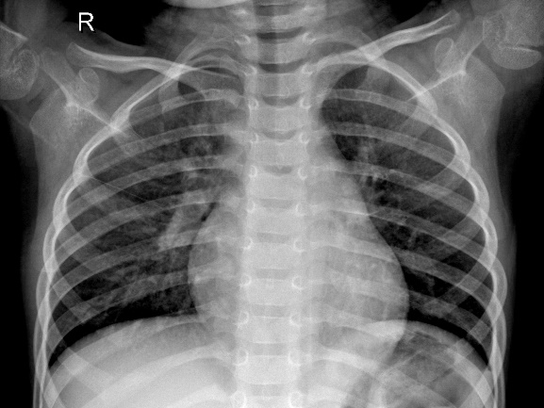

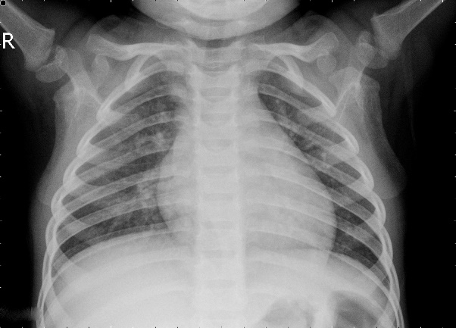

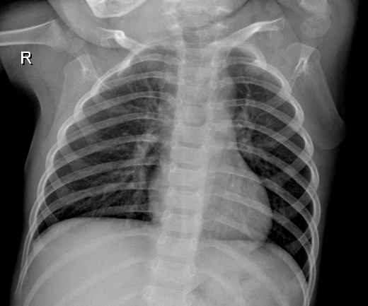

1 NORMAL

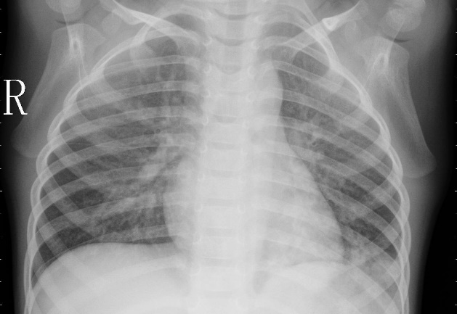

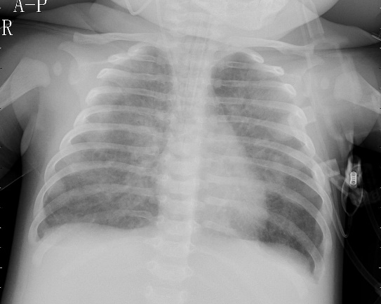

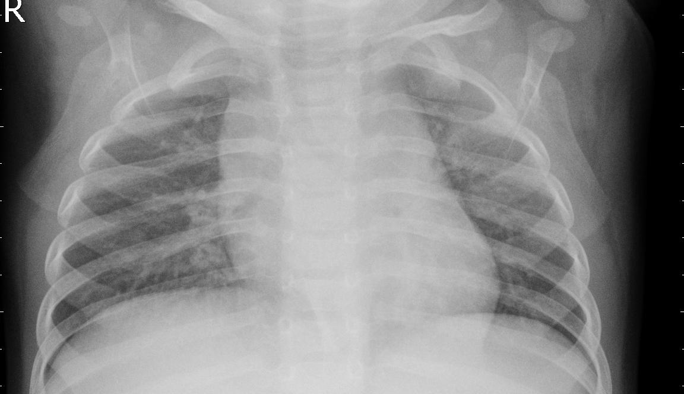

2 PNEUMONIA

**5.1.2 Data Splitting:** The dataset we sourced was already split into train, test and val sets for our convenience. The directory structure is as such:

Chest X-Ray

--------- chest_xray

------------------ test

--------------------------- NORMAL

--------------------------- PNEUMONIA

------------------ train

--------------------------- NORMAL

--------------------------- PNEUMONIA

------------------ val

--------------------------- NORMAL

--------------------------- PNEUMONIA

Splitting the dataset helps in training the model, tuning hyperparameters and evaluating the model’s performance on unseen data.

**5.1.3 Data Preprocessing:**

This involves resizing, normalization, and other transformations to ensure consistency and reduce noise in the data.

For our data we rescale the image, resize and normalize the image depending on the models.

**5.1.4 Model Selection:**

For our work we have used a wide assortment of both custom and pretrained CNN models, a total of 7, of which 2 are custom sequential CNN models while the rest are pretrained CNN models on the ImageNet [18] dataset.

**5.1.5 Model Training:**

Train the selected model using the training dataset. During training, the model learns to recognize patterns and features associated with pneumonia in the images. Use the validation set to monitor the model's performance and avoid overfitting.

[NOTE: We train our models for 10 epochs due to time and resource constraints.]

**5.1.6 Model Evaluation:**

Once our models are trained, we check for their accuracy and test score and then compare said accuracy and test scores to identify the best trained model.

**5.1.7 Model Testing:**

Once our models and we identify the best model, using it we write a code to distinguish between NORMAL and PNEUMONIA X-Ray images.

**5.1.8 Frontend development:**

For our frontend we use the best model and the test code we wrote for said model. Our frontend consists of a very basic user interface. The elements include:

1. A welcome page with,
2. A directive that reads, “*Please upload the X-ray of your lungs”*
3. A box with a button named, “Choose file” which when clicked lets us upload an image file.
4. Once uploaded it displays the file name and if we wish to change the file, we re-click the “Choose file” button.
5. If no file is uploaded a message reading, “Please select a file” is displayed.
6. If the image uploaded is classified as a NORMAL image a message reading, “You Are Safe!!” is displayed with a few emoticons.
7. If the image uploaded is classified as a PNEUMONIA image a message reading, “You have Pneumonia!!” is displayed with a few emoticons.
8. If one wishes to check with a different X-ray without navigating back we can click on the “Check Again” button which redirects us to the home page.

**5.1.9 Deployment:**

Currently we have only been able to deploy our model and frontend locally, and can only be used on a local machine with all necessary resources available. We plan to deploy our model and frontend for global access at a later date.

* 1. **Models Used:**

**5.1.1 Simple CNN:**

* + *Architecture:* A basic CNN typically consists of alternating convolutional layers and pooling layers. It starts with a convolutional layer that detects low-level features like edges and gradually moves to deeper layers for more complex features. The final layers are often fully connected for classification.
  + *Use Case:* Suitable for simple image classification tasks where the data does not require a highly complex model.

**5.1.2 Complex CNN:**

* + *Architecture:* This term doesn't refer to a specific architecture but rather suggests a CNN with a more intricate design. It includes additional layers, such as batch normalization, dropout, or more complex connectivity patterns.
  + *Use Case:* Applied to more challenging tasks or datasets where a higher model capacity is needed.

**5.1.3 DenseNet121:**

* + *Architecture:* DenseNet (Densely Connected Convolutional Networks) connects each layer to every other layer in a feedforward fashion. DenseNet121 specifically has 121 layers and consists of dense blocks where layers are densely connected.
  + *Key Feature:* Encourages feature reuse and helps alleviate the vanishing gradient problem.
  + *Use Case:* Excellent performance on image classification tasks, especially with limited data.

**5.1.4 ResNet50V1 and ResNet50V2:**

* + *Architecture:* ResNet (Residual Network) introduced residual learning, where shortcuts or skip connections are added to the traditional layers, allowing the model to learn residual functions. ResNet50V1 and ResNet50V2 both have 50 layers.
  + *Key Feature:* Addresses the vanishing gradient problem and enables training of very deep networks.
  + *Use Case:* Commonly used for image classification, object detection, and other computer vision tasks.

**5.1.5 InceptionV3:**

* + *Architecture:* InceptionV3, part of the Inception architecture series, utilizes inception modules, combining multiple filter sizes in parallel to capture features at different scales.
  + *Key Feature:* Efficient at capturing spatial hierarchies and patterns through diverse filter sizes.
  + *Use Case:* Excellent for image classification tasks and widely used in transfer learning scenarios.

**5.1.6 VGG16:**

* + *Architecture:* The VGG (Visual Geometry Group) architecture is characterized by its simplicity. VGG16 specifically has 16 layers, all with small 3x3 convolutional filters.
  + *Key Feature:* Simplicity and uniformity in design, making it easy to understand and implement.
  + *Use Case:* Good for various computer vision tasks, especially when computational resources are sufficient.

**Results and Discussions**

The accuracy and loss of each of the models we used during training is depicted in table **6.1.1:**

The accuracy and loss on the test set after model train is depicted in table **6.1.2:**

[NOTE: The accuracy and loss values observed while training the models have been multiplied 100 times and rounded to the nearest whole number for better representation.]

**References**

1. K Madhavi, *Algorithm Selection and Model Evaluation in Application Design Using Machine Learning*, Lecture Notes in Computer Science. 12081 LNCS, pp. 175-195, 2020.
2. Chandrika Lingala, and Karanam Madhavi, *A Hybrid Framework for Heart Disease Prediction Using Machine Learning Algorithms*, E3S Web of Conferences 309, 01043, ICMED 2021, (2021). https://doi.org/10.1051/) e3sconf/202130901043.
3. B. Sankara Babu, Bhavita Mandapati, Bhavana Mandapati, Harshith Nallapu, Prasenjeet Samanta, K. Maithil, *Performance Comparison of CNN and DNN Algorithms for Automation of Diabetic Retinopathy Disease*, E3S Web Conf. 430 01075 (2023), DOI: 10.1051/e3sconf/202343001075.
4. D. Varshni, K. Thakral, L. Agarwal, R. Nijhawan and A. Mittal, *Pneumonia Detection Using CNN based Feature Extraction*, 2019 IEEE International Conference on Electrical, Computer and Communication Technologies (ICECCT), Coimbatore, India, 2019, pp. 1-7, doi: 10.1109/ICECCT.2019.8869364.
5. Alapat, Daniel Joseph et al. *A Review on Detection of Pneumonia in Chest X-ray Images Using Neural Networks.* Journal of biomedical physics & engineering vol. 12,6 551-558. 1 Dec. 2022, doi:10.31661/jbpe.v0i0.2202-1461
6. Rahman T., Chowdhury M., Khandakar A., Islam K., Islam K., Mahbub Z., et al. Transfer learning with deep convolutional neural network (CNN) for pneumonia detection using chest X-ray. *Applied Sciences*. 10, 3233 (2020)
7. Liang G. & Zheng L. A transfer learning method with deep residual network for pediatric pneumonia diagnosis. *Computer Methods And Programs In Biomedicine*. 187 pp. 104964 (2020) pmid:31262537
8. Ibrahim A., Ozsoz M., Serte S., Al-Turjman F. & Yakoi P. Pneumonia classification using deep learning from chest X-ray images during COVID-19. *Cognitive Computation*. pp. 1–13 (2021) pmid:33425044
9. Zubair S. An Efficient Method to Predict Pneumonia from Chest X-Rays Using Deep Learning Approach. *The Importance Of Health Informatics In Public Health During A Pandemic*. 272 pp. 457 (2020)
10. Deng J., Dong W., Socher R., Li L., Li K. & Fei-Fei, L. *Imagenet: A large-scale hierarchical image database*. 2009 IEEE Conference On Computer Vision And Pattern Recognition. pp. 248-255 (2009)
11. Chandra T. & Verma K. Pneumonia detection on chest X-Ray using machine learning paradigm. *Proceedings Of 3rd International Conference On Computer Vision And Image Processing*. pp. 21-33 (2020)
12. Kuo K., Talley P., Huang C. & Cheng L. Predicting hospital-acquired pneumonia among schizophrenic patients: a machine learning approach. *BMC Medical Informatics And Decision Making*. 19, 1–8 (2019) pmid:30866913
13. Yue H., Yu Q., Liu C., Huang Y., Jiang Z., Shao C., et al. & Others Machine learning-based CT radiomics method for predicting hospital stay in patients with pneumonia associated with SARS-CoV-2 infection: a multicenter study. *Annals Of Translational Medicine*. 8 (2020) pmid:32793703
14. Sharma H., Jain J., Bansal P. & Gupta S. Feature extraction and classification of chest x-ray images using cnn to detect pneumonia. *2020 10th International Conference On Cloud Computing*, *Data Science* & *Engineering (Confluence)*. pp. 227-231 (2020)
15. Stephen O., Sain M., Maduh U. & Jeong D. An efficient deep learning approach to pneumonia classification in healthcare. *Journal Of Healthcare Engineering*. 2019 (2019) pmid:31049186
16. Kermany D., Zhang K. & Goldbaum M. Labeled Optical Coherence Tomography (OCT) and Chest X-Ray Images for Classification. (Mendeley,2018)
17. Rajpurkar P., Irvin J., Zhu K., Yang B., Mehta H., Duan T., et al. & Others Chexnet: Radiologist-level pneumonia detection on chest x-rays with deep learning. *ArXiv Preprint ArXiv*:*1711*.*05225*. (2017)
18. J. Deng, W. Dong, R. Socher, L. -J. Li, Kai Li and Li Fei-Fei, *ImageNet: A large-scale hierarchical image database*, 2009 IEEE Conference on Computer Vision and Pattern Recognition, Miami, FL, USA, 2009, pp. 248-255, doi: 10.1109/CVPR.2009.5206848.